**Assignment 10**

**KD1-Indrajeet-86641**

Q1. Write a query that produces all pairs of salespeople who are living in the same city. Exclude combinations of salespeople with themselves as well as duplicate rows with the order reversed.

🡺 **select a.sname, b.sname from salespeople a, salespeople b**

**where a.city = b.city and a.sname > b.sname;**

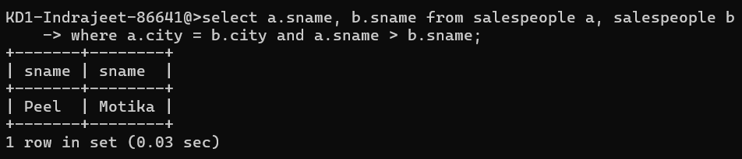

Q2. Write a query that produces the names and cities of all customers with the same rating as Hoffman.

🡺 **select cname, city from customers where**

**rating = (select rating from customers where cname = 'Hoffman');**

